Task1)

SELECT c.customer_name, l.loan_number FROM ((customer c INNER JOIN borrower b ON c.customer_id = b.customer_id ) INNER JOIN loan l ON b.loan_number = l.loan_number) WHERE l.branch_name = 'Downtown';

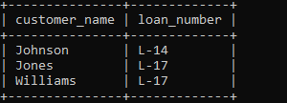

Task2)

SELECT c1.customer_name AS Customer1, c2.customer_name AS Customer2, c1.customer_city FROM customer c1 INNER JOIN customer c2 ON c1.customer_city = c2.customer_city WHERE c1.customer_id != c2.customer_id;

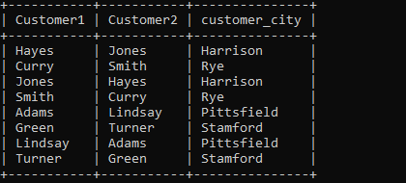

Task3)

SELECT branch_name as Branch_name, (SUM(balance)*4)/100 AS Total_Interest FROM account GROUP BY branch_name;

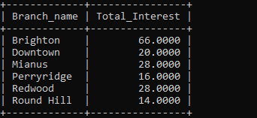

Task4)

SELECT b.branch_city, a.Account_Number FROM branch b , account a, (SELECT b.branch_city, MAX(a.balance) AS Highest_Balance FROM branch b INNER JOIN account a ON b.branch_name = a.branch_name GROUP BY b.branch_city) c WHERE b.branch_name = a.branch_name AND b.branch_city = c.branch_city AND a.balance = c.Highest_Balance;

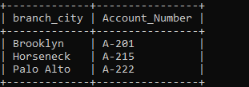

Task5)

SELECT c.customer_name, l.loan_number, l.amount FROM ((customer c INNER JOIN borrower b ON c.customer_id=b.customer_id) INNER JOIN loan l ON b.loan_number=l.loan_number) ORDER BY l.amount ASC, l.loan_number DESC limit 5;

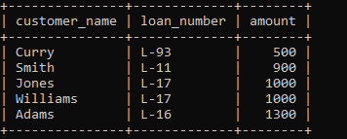

Task6)

SELECT c.customer_name FROM customer c, depositor d, borrower b, loan l WHERE c.customer_id=d.customer_id

AND c.customer_id=b.customer_id AND b.loan_number=l.loan_number and l.branch_name="Perryridge";



Task7)

SELECT SUM(amount) as "total_loan" FROM loan WHERE loan_number IN(SELECT loan_number FROM borrower WHERE customer_id

IN (SELECT customer_id FROM borrower GROUP BY customer_id HAVING COUNT(customer_id)>1));

